20th November 2024

AI Applications in Healthcare: Wrist Fracture Detection Using YOLO-v9

Suseel Mathusoothanan1, Maddala Sai Riship2, Dhashwanth Bharathi3

1Register Number: 21BCE1645, SCOPE

2Register Number: 21BCE1600, SCOPE

3Register Number: 21BCE1553, SCOPE

This work, which forms part of the curriculum at Vellore Institute of Technology, is a project centred on Artificial Intelligence

ABSTRACT Wrist fractures are common injuries that require prompt diagnosis and treatment to prevent long-term complications. In this study, we propose a novel approach for wrist fracture detection using YOLOv9, a state-of-the-art object detection algorithm. The proposed method leverages deep learning techniques to automatically detect wrist fractures in X-ray images with high accuracy and efficiency. By training the YOLOv9 model on a large dataset of annotated X-ray images, we demonstrate superior performance in terms of both accuracy and speed compared to traditional methods. Our experimental results show promising outcomes, suggesting that the proposed approach has the potential to assist radiologists in diagnosing wrist fractures more effectively, ultimately leading to better patient outcomes and reduced healthcare costs.

INDEX TERMS Accuracy, Deep learning, Detection, Diagnosis, Efficiency, Healthcare, Mean Average Precision (mAP), Object detection, Radiologists, Wrist fractures, X-ray images, YOLOv9

I. INTRODUCTION

Wrist fractures represent a significant burden in healthcare systems worldwide, accounting for a substantial portion of orthopedic injuries. Prompt and accurate detection of wrist fractures is crucial for effective treatment and long-term patient outcomes. However, existing methods for wrist fracture detection often face challenges in terms of accuracy, efficiency, and reliance on radiologist expertise.

Current approaches to wrist fracture detection, particularly manual interpretation of X-ray images by radiologists, are prone to human error and subjectivity. Misinterpretation or oversight of fractures can lead to delayed diagnosis and inappropriate treatment, impacting patient recovery and increasing healthcare costs. Moreover, the sheer volume of X-ray images that radiologists must review daily can result in fatigue and decreased accuracy over time. Additionally, traditional computer-aided detection systems may lack the robustness and adaptability required to effectively identify fractures in diverse patient populations and imaging conditions.

To address the challenges associated with wrist fracture detection, advanced techniques such as deep learning-based object detection algorithms like YOLOv9 can offer promising solutions. By leveraging deep learning, these algorithms can automatically extract relevant features from X-ray images and accurately localize fractures with high precision. Furthermore, deep learning models can be trained on large datasets to improve generalization across different imaging modalities and patient demographics. Additionally, integrating artificial intelligence (AI) systems into clinical workflows can assist radiologists by providing real-time decision support, reducing interpretation time, and enhancing diagnostic accuracy. Such AI-powered tools have the potential to revolutionize wrist fracture detection by augmenting radiologist expertise and improving patient care outcomes.

Key contributions in this work include the development and implementation of a novel deep learning-based wrist fracture detection system using YOLOv9, collecting and ensuring the dataset represents diverse demographics and fracture types to enhance the model's generalization capabilities. It also includes implementing and fine-tuning the YOLOv9 architecture for wrist fracture detection by Optimizing hyperparameters, data augmentation techniques, and regularization strategies to improve model performance and robustness.

II. LITERATURE REVIEW

Authors of [6] explore the use of deep generative models in precision medicine, focusing on their impact on clinical informatics, medical imaging, bioinformatics, and early diagnostics. The review emphasizes the application of advanced deep generative models like Generative Adversarial Networks (GANs) and Variational Autoencoders (VAEs) in addressing challenges such as data scarcity, privacy concerns, and ethical considerations in personalized medicine. It evaluates the performance and limitations of generative AI methods across various datasets, demonstrating their efficacy in addressing specific healthcare challenges. The review also highlights the importance of interdisciplinary research to fully harness the potential of generative AI in healthcare, showcasing its transformative role in personalized medicine.

The authors of [7] explore the use of artificial intelligence (AI) in personalized medicine, focusing on AI-generated personalized therapy plans based on genetic and medical histories. It emphasizes the potential of AI in advancing personalized medicine while acknowledging the challenge of analyzing extensive datasets for tailored treatment approaches. The integration of AI into personalized treatment requires adjustments in healthcare infrastructure, diagnostics, business models, payment policies, and regulatory oversight. The paper discusses the transformative impact of personalized medicine, highlighting the pivotal role of AI in developing personalized treatment plans and addressing ethical, privacy, and data security concerns. It underscores the potential of AI to revolutionize healthcare delivery, contingent upon effectively addressing challenges related to data quality, ethical and privacy concerns, and the development of accurate AI algorithms. Additionally, the paper discusses the role of Health Information Management (HIM) professionals in managing genomic data and the importance of increased collaboration and data sharing among healthcare providers. Overall, it offers a comprehensive examination of the implications, challenges, and potential solutions related to integrating AI in personalized medicine, providing insights into the future of AI-driven personalized therapy plans.

George, A.s et al. [8] delve into the impact of artificial intelligence (AI) and medical automation on the field of medicine, tracing the historical shift from a predominantly personal approach to a more data-driven and technologically advanced model. It explores the implications of this evolution, weighing the advantages and disadvantages of integrating AI into medical practice. While recognizing the potential benefits of AI in medicine, such as more efficient diagnoses, treatment recommendations, cost reduction, and enhanced accessibility, the paper also acknowledges potential drawbacks. These include concerns about reduced personalization in patient care, over-reliance on technology, and the potential displacement of human roles within the healthcare system. It identifies specific areas within medicine ripe for automation, including diagnostic specialties like pathology, radiology, and dermatology, as well as medical billing and administration. Additionally, it contemplates the future role of human doctors in the era of AI, stressing the importance of maintaining human skills such as empathy and interpersonal communication. Furthermore, the paper advocates for a collaborative approach between doctors and AI, emphasizing augmentation rather than replacement. It suggests that technology should complement human strengths and purposes in healthcare, rather than supplanting them entirely. Ultimately, the paper concludes by discussing the ideal balance between AI efficiency and human connection in medicine, advocating for the integration of emerging technologies while preserving the compassionate and ethical aspects of healthcare. It underscores the importance of responsible implementation of AI in medicine, ensuring that technology enhances rather than diminishes the human-centric nature of healthcare delivery.

The authors of [9] "Towards Autonomous Healthcare: Integrating Artificial Intelligence (AI) for Personalized Medicine and Disease Prediction" explores the significant impact of AI on autonomous healthcare, focusing on personalized medicine and disease prognosis. It emphasizes AI's potential in enhancing diagnostic accuracy, treatment effectiveness, and healthcare outcomes through the analysis of vast datasets encompassing genomics, proteomics, and patient records. The paper also highlights the crucial role of AI-driven proteomic analysis and medical imaging in shaping personalized medicine, as well as AI's potential in disease prediction through machine learning algorithms. Addressing ethical considerations and challenges associated with AI integration in healthcare, the paper advocates for responsible and transparent utilization of these technologies, envisioning a future where medical practices are tailored to individual patient needs. It provides a comprehensive framework for AI integration in personalized medicine and disease prediction, while acknowledging challenges related to data privacy and security, regulatory compliance, ethical and legal concerns, and cost and resource constraints. Overall, the paper offers valuable insights into the transformative potential of AI in healthcare, emphasizing ethical considerations, challenges, and prospects of AI integration in healthcare for a more resilient and patient-centric healthcare ecosystem.

Authors of [10] revolve around the prospects of personalized medicine and pharmacogenomics, with a focus on the potential influence of ChatGPT, an AI tool, in forecasting the trajectory of these fields. It highlights the promising prospects of personalized medicine, which customizes medical decisions based on genetic makeup, and the role of pharmacogenomics in optimizing treatment by considering genetic variations in drug response. ChatGPT's insights address distinctions between precision and personalized medicine, economic implications, the evolution of pharmacogenomics, and the transition from evidence-based to precision-based medicine. It emphasizes the broader inclusion of lifestyle and environmental factors in personalized medicine, the economic benefits of precision medicine, and the potential of pharmacogenomics to enhance drug safety, efficacy, and tailored treatment approaches. The discussion also acknowledges the necessity for technological advancements, changes in clinical protocols, and patient acceptance in the transition to precision-based medicine. While recognizing the potential of AI, the paper stresses the importance of human expertise, thorough assessment, validation, and quality assurance of training datasets before incorporating AI into research and educational settings. It concludes by highlighting the need for comprehensive training, education, and regulatory approval for the implementation of personalized medicine and pharmacogenomics, while emphasizing the careful validation and consideration of AI's limitations. Overall, the discussion underscores the substantial impact of precision medicine and pharmacogenomics on patient outcomes, healthcare expenditures, and drug development, indicating their potential as areas for substantial investment and innovation.

Johnson, Kevin et al [11] provides an overview of health determinants, emphasizing the substantial impact of behavioral, social, and genetic factors on individual health outcomes. It introduces the concept of big data in healthcare, highlighting its potential value and transformative impact on healthcare delivery, research, and decision-making processes. Additionally, it delves into the potential of precision medicine, artificial intelligence (AI), and personalized health in reshaping the healthcare landscape, emphasizing their promise in enabling more precise diagnoses, predicting disease risk, and designing customized treatment plans. The paper underscores the significance of incorporating environmental considerations, detecting and mitigating bias in health data, and promoting equitable healthcare delivery for improved patient outcomes.

Authors of [12] explore the integration of Artificial Intelligence (AI) into personalized healthcare, emphasizing its impact on diagnostics, treatment strategies, predictive analytics, ethical considerations, and future developments. It highlights AI's role in refining diagnostic precision, crafting individualized treatment plans, facilitating proactive disease management, and improving clinical decision-making. Ethical concerns related to data confidentiality, algorithmic biases, and accountability are addressed, along with potential advancements in AI technology. The paper emphasizes the need for ethical innovation, collaboration among stakeholders, healthcare professional education, and responsible AI incorporation to ensure superior patient outcomes and a more patient-centric healthcare system.

Lanotte, Francesco. et al [13] discusses the application of artificial intelligence in rehabilitation medicine, focusing on interpreting medical images, collecting biometric data through wearable sensors, and proposing an AI development framework. It emphasizes the importance of intuitive and relevant data, data annotations, and integrating new training data for AI model performance. The challenges and advances in using wearable sensors for lower extremity biomechanics are explored, along with the anonymization of healthcare data through generative adversarial networks. The paper stresses the necessity of creating interpretable AI tools and highlights the challenges and opportunities in AI for rehabilitation medicine, providing insights into its potential to optimize function and add value to healthcare.

The authors of [15] outlines the development of Vinci Medicine, a comprehensive healthcare platform utilizing machine learning and mobile technology. It integrates a mobile app, administrative dashboard, machine learning module, and database, allowing users to input symptoms and receive tailored medical advice. The system empowers staff to manage appointments seamlessly and offers initial diagnoses and test recommendations. Crafted using Python 3.10 and FastAPI, with MariaDB as the database backbone, Vinci Medicine consistently delivers accurate diagnoses and relevant medical assessments, providing users with convenient access to medical guidance and services directly from their mobile devices.

Abdelhalim, Habiba et al [20] delve into the intersection of artificial intelligence, healthcare, clinical genomics, and pharmacogenomics in the context of precision medicine. It emphasizes the pivotal role of big data initiatives and the decreasing costs of DNA-sequencing techniques in advancing precision medicine. The significance of gene-disease databases is underscored, particularly in their potential to revolutionize the treatment of genetic diseases. Furthermore, the applications of pharmacogenomics in drug manufacturing, distribution, and prescription are discussed in detail. The document highlights the critical importance of clinical genomics, AI, big data, and pharmacogenomics in shaping the future of precision medicine. It underscores the potential of these technologies to drive advancements in personalized healthcare, disease treatment, and drug development. The integration of AI and big data in healthcare is identified as a key enabler for improving patient care and outcomes. Moreover, the document emphasizes the potential of gene-disease databases to facilitate the identification of genetic variations and their associated diseases. This has significant implications for the development of targeted therapies and personalized treatment plans for patients with genetic disorders. The applications of pharmacogenomics in drug development and prescription are explored, with a focus on leveraging genetic information to optimize drug efficacy and minimize adverse reactions. The document underscores the potential of pharmacogenomics to enhance the safety and effectiveness of medications, thereby improving patient outcomes. In conclusion, the document underscores the transformative potential of clinical genomics, AI, big data, and pharmacogenomics in advancing precision medicine. It emphasizes the need for continued research and innovation in these areas to realize the full potential of personalized healthcare and precision medicine. The integration of these technologies is positioned as a cornerstone for driving advancements in disease treatment, drug development, and patient care.

The authors, Chun-Tse Chien, Rui-Yang Ju, Kuang-Yi Chou and Jen-Shiun Chiang, [22] highlight the significant advancements in fracture detection facilitated by the integration of attention mechanisms into the YOLOv8 architecture. The study underscores the potential of these models to enhance diagnostic accuracy and improve patient outcomes in cases of wrist trauma and fractures. The use of neural networks, particularly the YOLO (You Only Look Once) series models, has become prevalent in the detection of fractures, especially in cases of wrist trauma and fractures, which are common occurrences in daily life, particularly among children. Prior to surgical intervention, surgeons often rely on X-ray imaging to assess the extent of the injury, with the analysis of the radiologist guiding the decision-making process. In 2023, Ultralytics introduced the latest iteration of the YOLO models, which have been effectively utilized for fracture detection across various parts of the body. Notably, attention mechanism has emerged as a prominent method for enhancing the performance of these models. The research work in question proposes the YOLOv8-AM, which integrates the attention mechanism into the original YOLOv8 architecture. This is achieved through the incorporation of four distinct attention modules: Convolutional Block Attention Module (CBAM), Global Attention Mechanism (GAM), Efficient Channel Attention (ECA), and Shuffle Attention (SA). These modules are integrated to design improved models, which are then trained on the GRAZPEDWRI-DX dataset.

Observing the papers, the challenges posed by AI integration in healthcare, including issues related to data privacy and security, data quality and integration, regulatory compliance, ethical and legal concerns, algorithm transparency and explainability, as well as cost and resource constraints can be identified.

These challenges were recognized as important considerations in the reviewed studies.

III. MATERIALS AND METHODS

A. ARCHITECTURE

The architecture of YOLOv9 includes many new techniques such as Programmable Gradient Information (PGI) and Generalized Efficient Layer Aggregation Network (GELAN) to effectively address issues related to information loss and computational efficiency, thereby setting a new standard for accuracy and speed in the field

The key components of the YOLOv9 architecture include: The Information Bottleneck Principle, Reversible Functions, Programmable Gradient Information (PGI), and the Generalized Efficient Layer Aggregate Network (GELAN).

The Information Bottleneck Principle underscores the phenomenon of information loss as data undergoes transformations within a neural network. It is quantified through the Information Bottleneck equation, which signifies the reduction in mutual information between the original and transformed data as they traverse the layers of a deep network.



Here, 'I' represents mutual information, while 'f' and 'g' denote transformation functions parameterized by θ and ϕ, respectively. The progression of data (X) through these network layers (fθ and gϕ) results in the loss of crucial information essential for accurate predictions. Consequently, this loss can lead to unreliable gradients and hinder the convergence of the model. While increasing the model's size is a common approach to augment its capacity for data transformation and retain more information, it fails to address the challenge of unreliable gradients in exceptionally deep networks.

To address the Information Bottleneck challenge, reversible functions offer a theoretical solution within neural networks. These functions ensure no loss of information during data transformation, allowing for the complete reconstruction of the original input data from the network's outputs.

In the aforementioned equation, 'r' and 'v' denote the forward and reverse transformations, respectively, with 'ψ' and 'ζ' representing their parameters. By employing reversible functions, networks can retain all input information across all layers, facilitating more accurate gradient calculations for model updates. However, while advantageous, reversible functions disrupt the conventional understanding of deep networks, particularly in addressing complex problems with models that are not inherently deep.

Upon applying reversible functions, the preservation of mutual information between the input and output becomes evident. This preservation ensures that the original input 'X' remains intact as it traverses through the layers using the transformation function 'r' and its inverse 'v'.

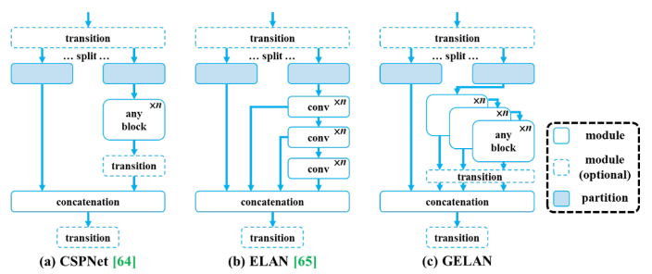Despite their benefits, reversible functions pose challenges for lightweight models due to under-parameterization, limiting their ability to handle extensive raw data without significant information loss. This limitation can adversely impact the model's performance by compromising its ability to preserve crucial data.

Considering the insights provided, there arises a necessity for a novel training method for deep neural networks. This method should yield dependable gradients for model updates while remaining suitable for shallow and lightweight architectures. Programmable Gradient Information (PGI) emerges as a solution, comprising a primary branch for inference and an auxiliary reversible branch for accurate gradient calculation. Additionally, PGI incorporates multi-level auxiliary information to effectively tackle deep supervision challenges without imposing extra inference costs.

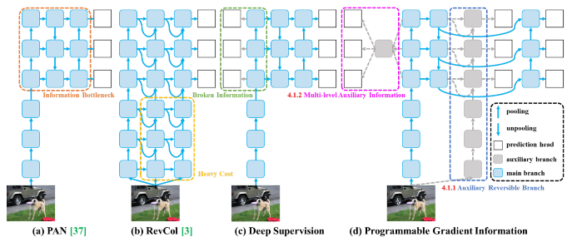To delve deeper into Programmable Gradient Information (PGI) within the YOLOv9 framework, it's crucial to understand its intricate design aimed at improving model training and efficiency. PGI encompasses an auxiliary supervision node dedicated to addressing the information bottleneck prevalent in deep neural networks. Its focus lies on ensuring precise and efficient backpropagation of gradients. PGI evolves through the integration of three components, each fulfilling a distinct yet interconnected role within the model's architecture.

FIGURE 1.  Architectural Representation of PAN, RevCAL, Deep Supervision and Programmable Gradient Information

With the introduction of Programmable Gradient Information (PGI) in YOLOv9, there arises a need for an even more sophisticated architecture. This is where the Generalized Efficient Layer Aggregation Network (GELAN) steps in. GELAN is specifically tailored to complement the PGI framework, thereby improving the model's efficacy in processing and learning from data.

GELAN builds upon the foundation laid by PGI, further enhancing the model's capability to retain essential information across deep neural networks. It achieves this by providing a flexible and efficient structure that supports a variety of computational blocks. By amalgamating the gradient path planning of CSPNet with the inference speed optimizations of ELAN, GELAN offers a versatile architecture that significantly enhances the YOLO family's renowned real-time inference capability.

FIGURE 2.  Architectural Representation of CSPNet, ELAN and GELAN

GELAN stands out as a lightweight framework that prioritizes rapid inference times without compromising accuracy. This attribute extends the applicability of computational blocks, making GELAN a promising addition to the YOLOv9 framework.

B. PROPOSED METHODOLOGY

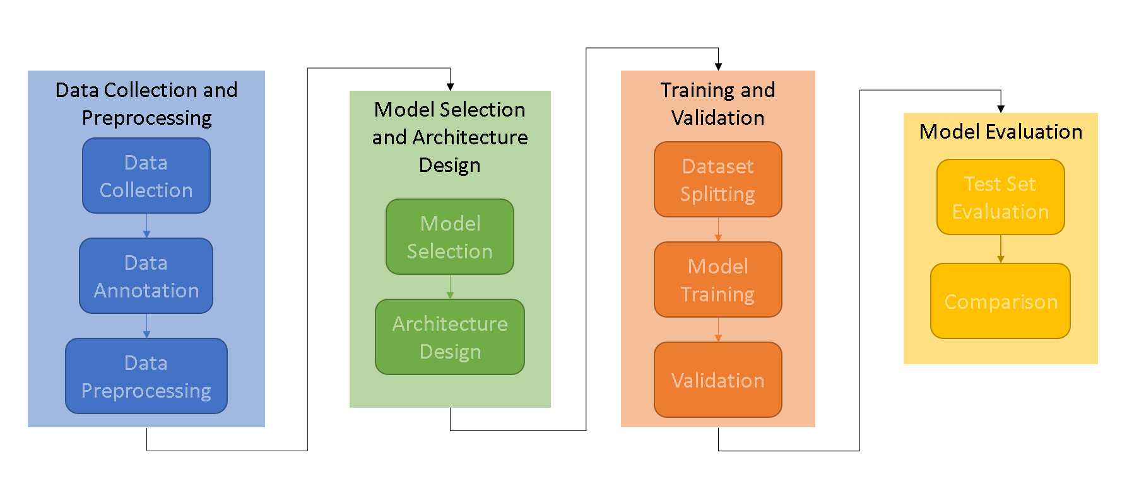

FIGURE 3.  Flowchart depicting the workflow of the experiment

Data Collection: Gather a diverse dataset of wrist X-ray images from medical archives, hospitals, and clinics. This dataset should include images of various fracture types, severities, and patient demographics to ensure the model's robustness and generalization capability.

Data Annotation: Annotate the X-ray images to mark the regions corresponding to wrist fractures. This annotation process involves identifying and delineating the fractures within the images. Annotation ensures that the model learns to detect fractures accurately during training.

Data Preprocessing: Preprocess the dataset to enhance its quality and facilitate model training. Preprocessing steps may include resizing the images to a uniform resolution, applying contrast enhancement techniques to improve visibility, and normalizing pixel values to ensure consistency across the dataset.

Model Selection: Choose a suitable deep learning architecture for object detection tasks. YOLOv9 is a popular choice due to its high accuracy and real-time performance.

Architecture Design: Modify the selected architecture to adapt it to the wrist fracture detection task. This may involve adjusting network parameters, input sizes, and output layers to accommodate the characteristics of wrist X-ray images and optimize detection performance.

Dataset Splitting: Divide the annotated dataset into training, validation, and test sets. The training set is used to train the model, the validation set is used to tune hyperparameters and monitor performance during training, and the test set is used to evaluate the final model's performance.

Model Training: Train the modified YOLOv9 model using the training dataset. During training, the model learns to identify wrist fractures by adjusting its internal parameters based on the provided input-output pairs (X-ray images and corresponding annotations).

Validation: Validate the trained model's performance on the validation set. This involves evaluating metrics such as accuracy, precision, recall, and F1 score to assess how well the model generalizes to unseen data and identify potential overfitting or underfitting issues.

Test Set Evaluation: Evaluate the performance of the trained model on the test set, which contains data that the model has not seen during training or validation. Measure metrics such as mean Average Precision (mAP), Intersection over Union (IoU), and accuracy to quantify the model's performance in detecting wrist fractures accurately.

Comparison: Compare the performance of the proposed deep learning-based approach against existing methods and benchmarks to demonstrate its effectiveness and superiority. This comparison helps validate the model's efficacy and highlights its potential advantages over traditional approaches.

C. EXPERIMENT

Dataset: Digital radiography is widely available and the standard modality in trauma imaging, often enabling to diagnose pediatric wrist fractures. However, image interpretation requires time-consuming specialized training. Due to astonishing progress in computer vision algorithms, automated fracture detection has become a topic of research interest. This paper presents the GRAZPEDWRI-DX dataset containing annotated pediatric trauma wrist radiographs of 6,091 patients, treated at the Department for Pediatric Surgery of the University Hospital Graz between 2008 and 2018. 10,643 studies (20,327 images) are available, typically covering posteroanterior and lateral projections. The dataset is annotated with 74,459 image tags and features 67,771 labeled objects. We de-identified all radiographs and converted the DICOM pixel data to 16-Bit grayscale PNG images. The filenames and the accompanying text files provide basic patient information (age, sex). Several pediatric radiologists annotated dataset images by placing lines, bounding boxes, or polygons to mark pathologies like fractures or periosteal reactions. They also tagged general image characteristics. This dataset is publicly available to encourage computer vision research. Information about the dataset was referenced from https://www.nature.com/articles/s41597-022-01328-z

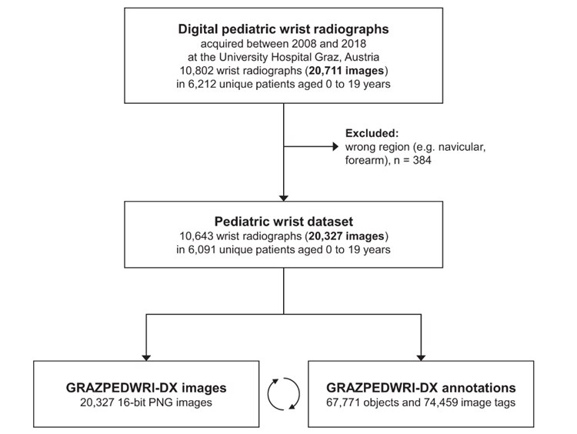

FIGURE 4.  Flowchart depicting the split of the dataset being used to train the models

Only 2813 images are being utilized from this dataset currently, due to hardware limitations such as GPU memory and power limit.

Environment Setup: The experiment employs the PyTorch deep learning framework to develop the model, benefiting from its adaptability and effectiveness in implementing complex neural network architectures. Additionally, the Ultralytics package is utilized to access the model and evaluate its performance metrics. The environment includes hardware resources such as GPUs to accelerate training processes, particularly when dealing with large-scale biomedical imaging datasets.

Performance Metrics: The experiment utilizes various performance metrics to evaluate the effectiveness of the model. These metrics include accuracy, precision, recall (sensitivity), F1 score, and mean Average Precision (mAP). Accuracy measures the proportion of correctly predicted instances, while precision indicates the ratio of correctly 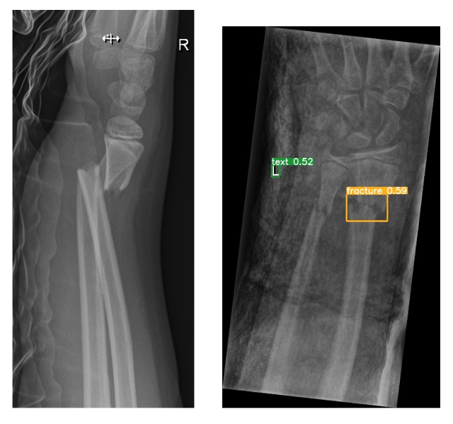predicted positive instances to the total predicted positive instances. Recall evaluates the proportion of correctly predicted positive instances to the total actual positive instances, and the F1 score provides a balance between precision and recall. Additionally, mean Average Precision (mAP) measures the average precision across all classes, offering a comprehensive assessment of the model's performance in object detection tasks.

IV. RESULTS

The trained models were used for detecting fractures and their corresponding statistical outputs such as Confusion matrix / Error matrix were generated to assess the model performances. ‘Box Loss vs. Epoch,’ and ‘mAP50 vs. Epoch’ graphs were also analyzed for each of the models.  
  
Two different iterations of the same model were carried out, with the differences being the number of epochs the model was trained for.

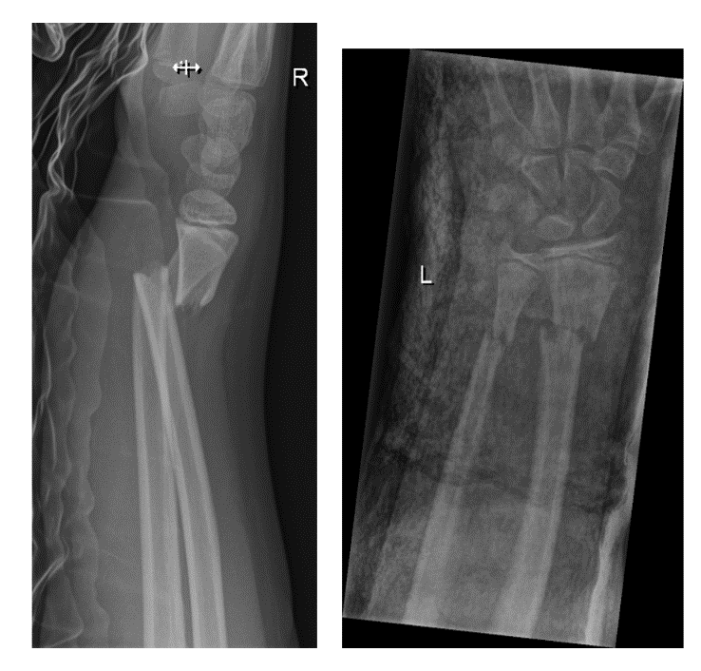The outputs were predicted for the following images:

FIGURE 5.  Sample images used for prediction

Iteration 1: Number of Epochs: 10

FIGURE 6.  Sample Images predicted using the model generated by Iteration 1

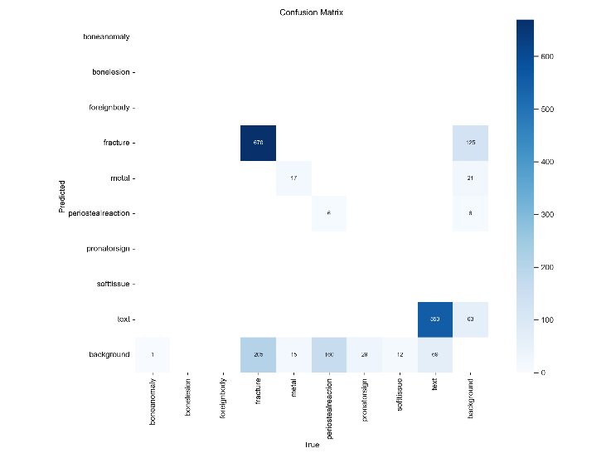

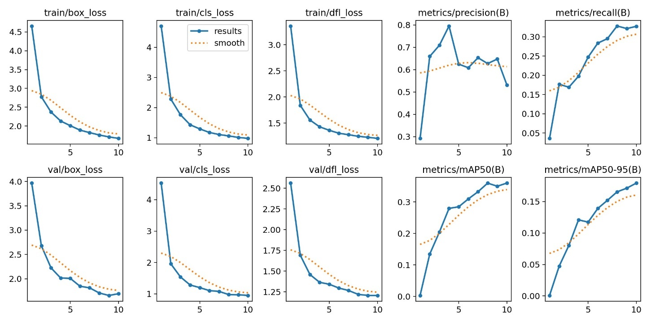FIGURE 7.  Confusion Matrix generated by the model given by Iteration 1

FIGURE 8.  Box Loss vs Epoch (Iteration 1)

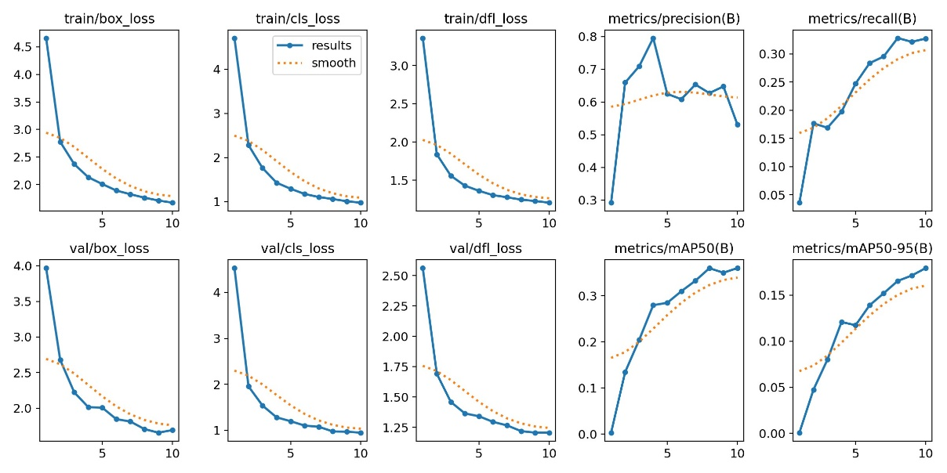FIGURE 9.  mAP50 vs Epoch (Iteration 1)

In this iteration, only one of the images has come out with a proper bounding box. Even that image does not give high enough confidence scores.

Iteration 2: Number of Epochs: 200

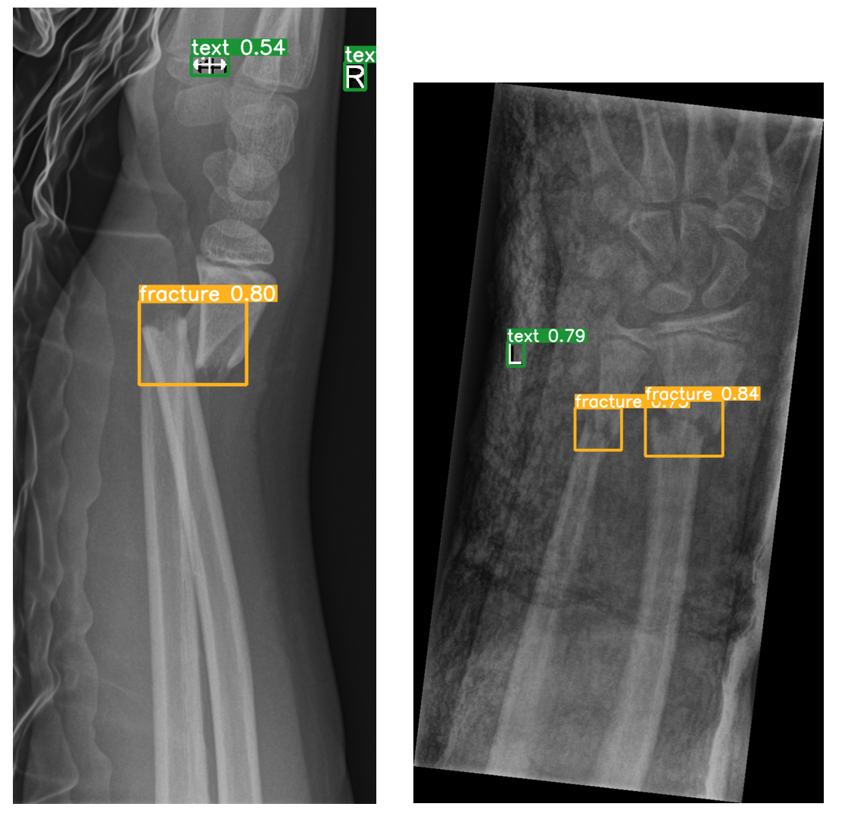

FIGURE 10.  Sample Images predicted using the model generated by Iteration 2

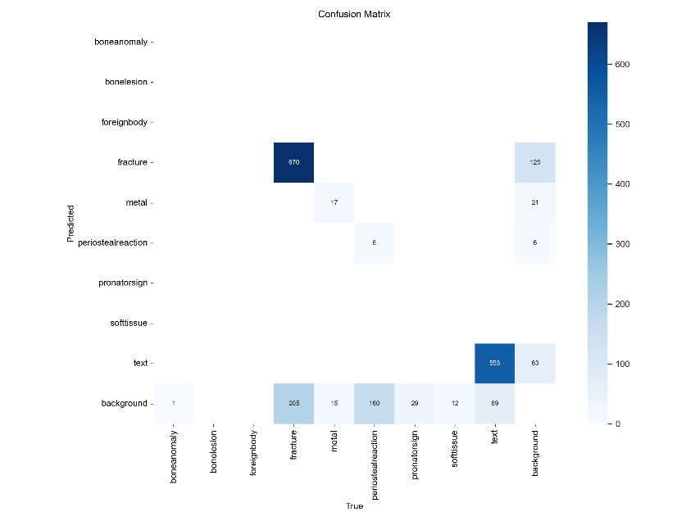

FIGURE 11.  Confusion Matrix generated by the model given by Iteration 2

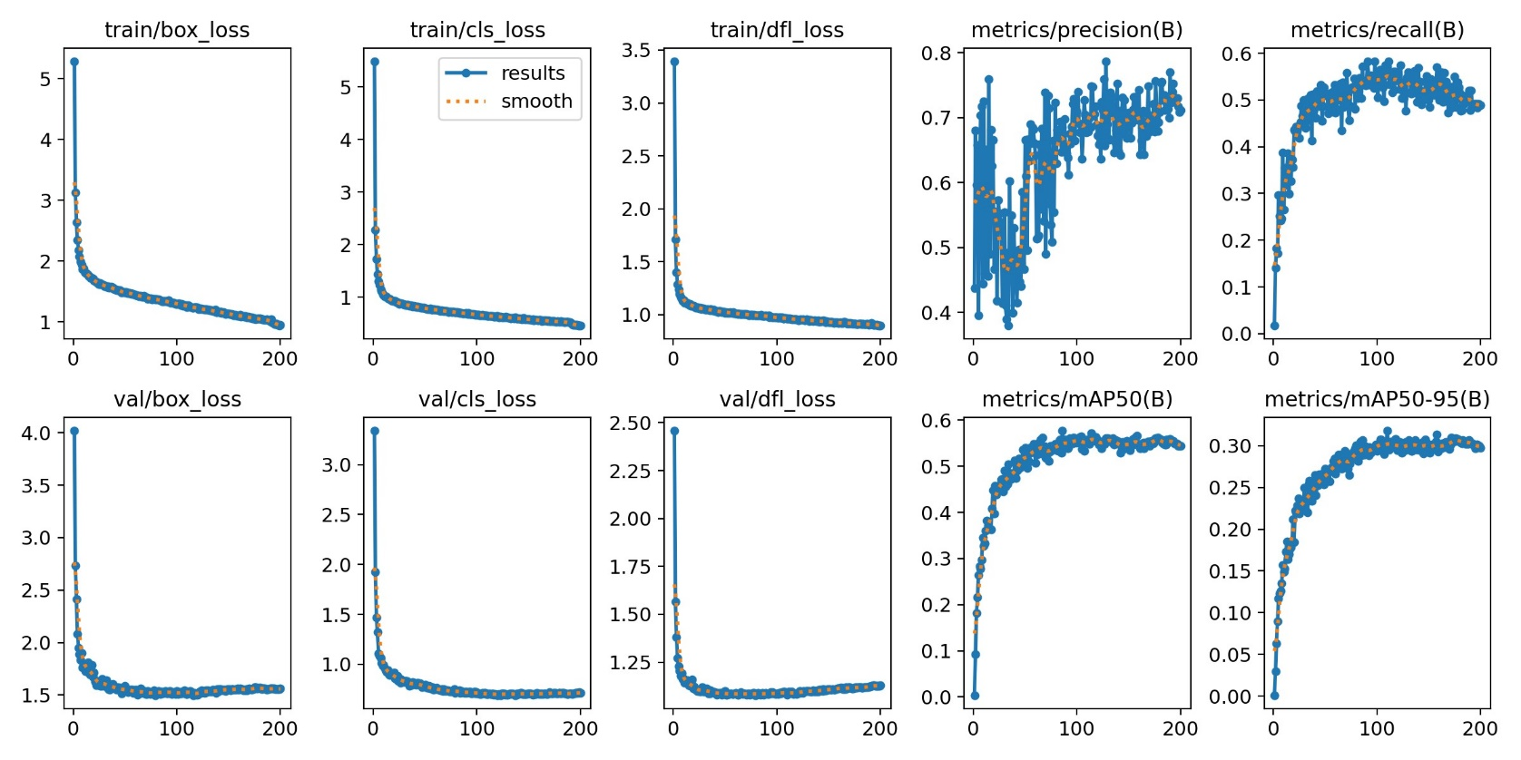

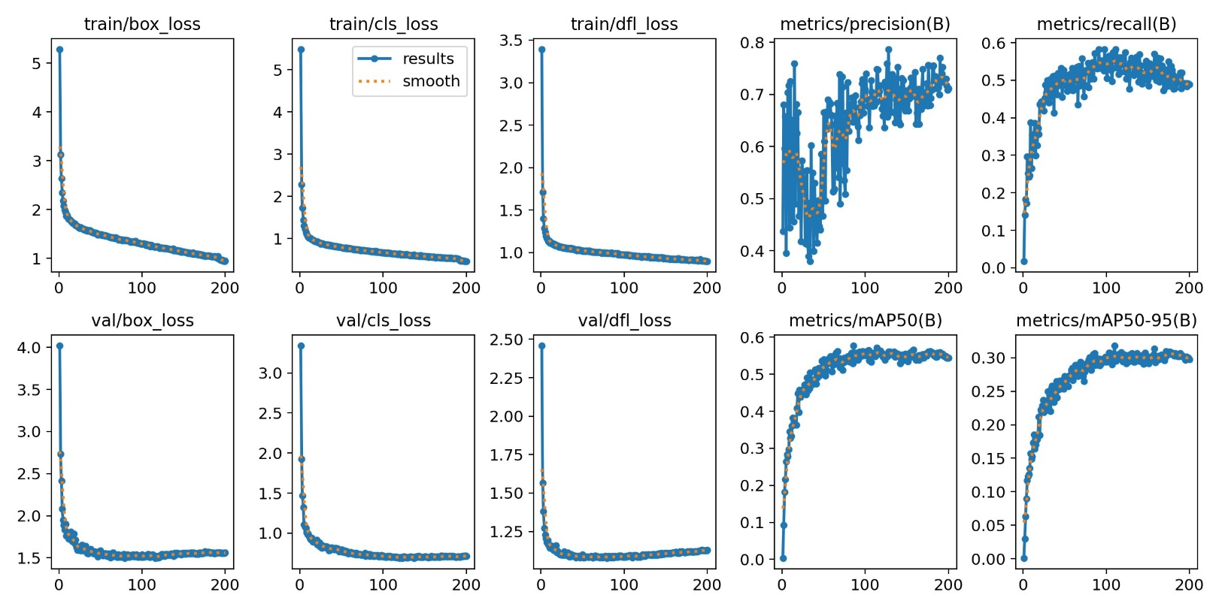FIGURE 12.  Box Loss vs Epoch (Iteration 2)

FIGURE 13.  mAP50 vs Epoch (Iteration 2)

In this iteration, both the images have come out with a good bounding box and a decent confidence score. Therefore, it can be concluded that this model performed better than the previous one.

V.  COMPARISONS

TABLE I

Comparison of models with existing models

|  |  |  |  |
| --- | --- | --- | --- |
| Model | F1 Score | mAP50 | mAP50-95 |
| YOLOv9  (10 epochs) | 0.40 | 35.98% | 17.95% |
| YOLOv9  (200 epochs) | 0.63 | 57.72% | 30.70% |
| YOLOv8  (existing model) | 0.62 | 63.58% | 40.40% |
| YOLOv8 + ResCBAM  (existing model) | 0.64 | 65.78% | 42.16% |

Comparing the results across different models reveals notable differences in performance metrics, particularly in F1 score and mAP at different thresholds.

YOLOv9 (10 epochs): This model demonstrates the lowest performance with an F1 score of 0.40 and mAP50 of 35.98%. The relatively short training duration likely contributes to its lower accuracy and precision compared to other models.

YOLOv9 (200 epochs): The performance significantly improves with longer training, yielding an F1 score of 0.63 and mAP50 of 57.72%. The substantial increase in both metrics highlights the importance of extended training durations in enhancing model accuracy and effectiveness.

YOLOv8 (existing model): This baseline model exhibits a competitive performance, with an F1 score of 0.62 and mAP50 of 63.58%. Despite being an existing model, YOLOv8 demonstrates robust performance across both metrics.

YOLOv8 + ResCBAM (existing model): Integrating ResCBAM into YOLOv8 further enhances its performance, resulting in an improved F1 score of 0.64 and higher mAP50 of 65.78%. This indicates the efficacy of architectural enhancements in boosting model accuracy and precision.

VI. DISCUSSION

The comparison of models reveals notable differences in performance metrics, particularly in F1 score and mAP at different thresholds. The YOLOv9 model, trained for 10 epochs, demonstrates relatively lower performance compared to its counterpart trained for 200 epochs. This highlights the significance of longer training durations in enhancing model accuracy and precision. Additionally, comparing YOLOv9 with existing models such as YOLOv8 underscores the incremental improvements achieved in mAP metrics. Interestingly, the integration of ResCBAM into YOLOv8 further enhances its performance, resulting in higher F1 scores and mAP values. These findings suggest that while YOLOv9 exhibits improvements over its predecessor, YOLOv8 with additional enhancements like ResCBAM continues to outperform in certain metrics. However, it's crucial to consider the trade-offs between model complexity, training time, and computational resources when selecting the most suitable model for specific applications. Further analysis and experimentation are warranted to elucidate the nuanced differences and determine the optimal model configuration for the intended task.

VII. CONCLUSION

The comprehensive evaluation and comparison of various models presented in this paper shed light on the advancements and nuances within the field of object detection. Through rigorous experimentation and analysis, key insights have been gleaned regarding the performance of different models, training durations, and architectural enhancements. The results indicate the efficacy of longer training durations in improving model accuracy and precision, as evidenced by the significant enhancements observed in F1 score and mAP metrics. Furthermore, the integration of novel techniques such as ResCBAM into existing models showcases the potential for further performance enhancements and underscores the importance of continuous innovation in model design. While YOLOv9 demonstrates promising improvements over its predecessors, the findings also highlight the continued relevance and effectiveness of established models like YOLOv8 with additional enhancements. Ultimately, this paper contributes to the evolving landscape of object detection by providing valuable insights, benchmarking results, and avenues for future research and development. As the field continues to evolve, the findings presented herein serve as a foundation for further exploration and innovation in object detection methodologies and technologies.

REFERENCES

1. Schork, N. J. (2019). Artificial intelligence and personalized medicine. Precision medicine in Cancer therapy, 265-283.
2. Chavali, D., Dhiman, V. K., & Katari, S. C. AI-Powered Virtual Health Assistants: Transforming Patient Engagement Through Virtual Nursing.
3. Hamburg, M. A., & Collins, F. S. (2010). The path to personalized medicine. New England Journal of Medicine, 363(4), 301-304.
4. Shaban-Nejad, A., Michalowski, M., & Bianco, S. (Eds.). (2023). Artificial Intelligence for Personalized Medicine: Promoting Healthy Living and Longevity (Vol. 1106). Springer Nature.
5. Rawat, B., Joshi, Y., & Kumar, A. (2023, August). AI in Healthcare: Opportunities and Challenges for Personalized Medicine and Disease Diagnosis. In 2023 5th International Conference on Inventive Research in Computing Applications (ICIRCA) (pp. 374-379). IEEE.
6. Ghebrehiwet, I., Zaki, N., Damseh, R., & Mohamad, M. S. (2024). Revolutionizing Personalized Medicine with Generative AI: A Systematic Review.
7. Parekh, A. D. E., Shaikh, O. A., Manan, S., & Al Hasibuzzaman, M. (2023). Artificial intelligence (AI) in personalized medicine: AI-generated personalized therapy regimens based on genetic and medical history. Annals of Medicine and Surgery, 85(11), 5831-5833.
8. George, A. H., & George, A. S. (2023). From Pulse to Prescription: Exploring the Rise of AI in Medicine and Its Implications. Partners Universal International Innovation Journal, 1(6), 38-54.
9. Rane, N., Choudhary, S., & Rane, J. (2023). Towards Autonomous Healthcare: Integrating Artificial Intelligence (AI) for Personalized Medicine and Disease Prediction. Available at SSRN 4637894.
10. Patrinos, G. P., Sarhangi, N., Sarrami, B., Khodayari, N., Larijani, B., & Hasanzad, M. (2023). Using ChatGPT to predict the future of personalized medicine. The Pharmacogenomics Journal, 23(6), 178-184.
11. Johnson, K. B., Wei, W. Q., Weeraratne, D., Frisse, M. E., Misulis, K., Rhee, K., ... & Snowdon, J. L. (2021). Precision medicine, AI, and the future of personalized health care. Clinical and translational science, 14(1), 86-93.\
12. Khan, A. (2023). Transforming Healthcare through AI: Unleashing the Power of Personalized Medicine. Int. J. Multidiscip. Sci. Arts, 2, 67-77.
13. Lanotte, F., O’Brien, M. K., & Jayaraman, A. (2023). AI in Rehabilitation Medicine: Opportunities and Challenges. Annals of Rehabilitation Medicine, 47(6), 444.
14. Hays, Priya. (2024). Personalized medicine: ‘Tyranny of the gene’. Open Access Government. 41. 105-107.
15. Kashpruk, N., Baranowski, J., & Bachta, W. (2023, August). Using AI for Healthcare Management–Vinci Medicine solution. In 2023 27th International Conference on Methods and Models in Automation and Robotics (MMAR) (pp. 123-126). IEEE.
16. Vadapalli, S., Abdelhalim, H., Zeeshan, S., & Ahmed, Z. (2022). Artificial intelligence and machine learning approaches using gene expression and variant data for personalized medicine. Briefings in bioinformatics, 23(5), bbac191.
17. Jamrat, S., Sukasem, C., Sratthaphut, L., Hongkaew, Y., & Samanchuen, T. (2023). A precision medicine approach to personalized prescribing using genetic and nongenetic factors for clinical decision-making. Computers in Biology and Medicine, 165, 107329.
18. DeFrank, J., & Luiz, A. (2022). AI-based personalized treatment recommendation for cancer patients. Journal of Carcinogenesis, 21(2).
19. Awwalu, J., Garba, A. G., Ghazvini, A., & Atuah, R. (2015). Artificial intelligence in personalized medicine application of AI algorithms in solving personalized medicine problems. International Journal of Computer Theory and Engineering, 7(6), 439.
20. Abdelhalim, H., Berber, A., Lodi, M., Jain, R., Nair, A., Pappu, A., ... & Ahmed, Z. (2022). Artificial intelligence, healthcare, clinical genomics, and pharmacogenomics approaches in precision medicine. Frontiers in genetics, 13, 929736.
21. Till, T., Tschauner, S., Singer, G., Lichtenegger, K., & Till, H. (2023). Development and optimization of AI algorithms for wrist fracture detection in children using a freely available dataset. Frontiers in Pediatrics, 11.
22. Chien, C. T., Ju, R. Y., Chou, K. Y., Lin, C. S., & Chiang, J. S. (2024). YOLOv8-AM: YOLOv8 with Attention Mechanisms for Pediatric Wrist Fracture Detection. arXiv preprint arXiv:2402.09329.